Multi-scale trend analysis of water quality using error propagation of generalized additive models

Marcus W. Beck ([mbeck@tbep.org](mailto:mbeck@tbep.org)), Perry de Valpine ([pdevalpine@berkeley.edu](mailto:pdevalpine@berkeley.edu)), Rebecca Murphy ([rmurphy@chesapeakebay.net](mailto:rmurphy@chesapeakebay.net)), Ian Wren ([ianw@sfei.org](mailto:ianw@sfei.org)), Ariella Chelsky ([ariellac@sfei.org](mailto:ariellac@sfei.org)), Melissa Foley ([melissaf@sfei.org](mailto:melissaf@sfei.org)), David B. Senn ([davids@sfei.org](mailto:davids@sfei.org))

Last manuscript build 2021-01-21 16:09:55

# Abstract

Accurate and flexible trend assessment methods are valuable tools for describing historical changes in environmental monitoring datasets. A key requirement is complete propagation of uncertainty through the analysis. However, this is difficult when there are mismatches between time scales of monitoring data and analysis methods. Here, we propose a novel application of Generalized Additive Models (GAMs) to model seasonal and multi-decadal changes in a long-term monitoring dataset of chlorophyll-a concentrations in South San Francisco Estuary. GAMs are a general method for modelling a response variable as the additive sum of one or more smoother splines fit to predictor variables. These models have shown promise in other applications to water quality monitoring data to separate long-term (i.e., annual or decadal) trends from seasonal variation. Our proposed methods estimate seasonal averages in a response variable with GAMs and then use those ancertainty with mixed-meta regression analyses to quantify inter-annual trends that account for full propagation of error across methods. We first demonstrate that nearly identical descriptions of temporal changes in l can be obtained using different smoothing splines for annual or seasonal components of the time series. We then extract seasonal averages for an a priori period of time within each year from the GAM results, including an accurate assessment of standard error within each year where the seasonal average is estimated. Finally, we demonstrate how trends can be quantified with mixed-meta regression analyses that evaluates changes in the seasonal averages between years with full propagation of uncertainty in the estimates. Overall, this approach leverages the ability of GAMs to identify an optimal amount of smoothing from the raw data and uses those results to accurately assess trends that minimize the likelihood of false positive or negative results, which is particularly important for time series with missing observations or varying sample effort over time.

# Introduction

Accurate quantification of trends must consider variation at different temporal scales regardless of the question of interest, such that ignoring variation at one scale could lead to incorrect conclusions about variation at another scale. Many environmental monitoring programs collect temporally resolved but irregular time-series data to quantify trends for regulatory, management, or research purposes. The mismatch between the scales of monitoring versus analysis questions or management goals can present statistical challenges (Urquhart et al. 1998, Cumming et al. 2006, Forbes and Xie 2018). At short temporal scales typically less than a year, environmental systems exhibit variability caused by multiple factors (e.g., weather events, management, or seasonal changes). Such fluctuations may not be of direct interest for inter-annual trends or may not be well-suited to multi-scale smoothing methods. In this paper, we describe methods to estimate across-year trends of within-year features of interest such as a seasonal average, seasonal peak, or seasonal timing of events, while accounting for uncertainties across analysis steps.

Existing methods that address our objectives in water quality trend analysis can be generalized into four basic approaches: seasonal Kendall tests, seasonal trend decomposition (STL), weighted regression on time, discharge, and season (WRTDS), and generalized additive models (GAMs). Seasonal Kendall tests or related non-parametric approaches have been used for decades in water quality trend assessments to identify monotonic changes over several years while accounting for the predictable patterns among seasons (Hirsch et al. 1982, Helsel et al. 2020). Wan et al. (2017) showed that non-parametric approaches have been the most commonly used methods in long-term water quality trend analysis despite critical limitations. For descriptive decomposition of long-term monitoring data, they assume seasonal patterns within year do not change, require regularly spaced or balanced data, only use time as a descriptor for trends, and do not estimate a model that could be useful for other purposes. Thus, while these non-parametric approaches have some degree of robustness to assess magnitude and direction of trends, they apply only to narrow goals.

The seasonal trend decomposition using loess (STL) decomposes a time series into additive components of a long-term trend, a seasonal pattern, and residuals (Cleveland et al. 1990, Cloern and Jassby 2010, Stow et al. 2015). While useful and widely applied, this method also has important limitations. STL decomposition does not incorporate explanatory variables besides time, it is defined more as an algorithm of statistical steps than as a coherent statistical model (e.g., Wan et al. 2017), and it does not usually estimate standard errors to allow hypothesis testing (but see Hafen 2010). STL methods may also over-simplify trends into absolute components that do not change over time, e.g., a seasonal estimate that is constant across years. This limitation presents challenges when addressing questions relevant to long-term water quality data, such as timing of seasonal peaks that can suggest system response to changing environmental conditions (Cloern and Jassby 2010, Navarro et al. 2012).

The weighted regression on time, discharge, and season (WRTDS) method addresses the problem of inflexibility in STL by using a more general local regression scheme (Hirsch et al. 2010, Beck and Hagy 2015, Beck et al. 2018). Designed for evaluating water quality in rivers where separating the effect of discharge on constituent concentration is important, WRTDS estimates a moving window regression model with components that allow parameters to vary smoothly in relation to both time and discharge. This yields parameters that are specific to season, year, and flow regime. The WRTDS approach is conceptually similar to localized multi-polynomial smoothing methods, with specific application to descriptive variables relevant for water quality constituents (i.e., season, year, and discharge). Standard error estimates of predictions from WRTDS are available through a “block bootstrap” approach that uses Monte Carlo estimates of false positive rates from the model results (Hirsch et al. 2015). Although a useful addition to the original method (Hirsch et al. 2010), the approach requires extensive resampling as a post-hoc application to a previously fitted model. Alternative methods that include standard error estimates simultaneously with model output may be preferred for intensive or more iterative applications

Generalized additive models (GAMs) are central to this paper and form the basis of our fourth and last method to separate fluctuations on different time scales. GAMs combine one or more smoothing splines to model patterns in data and may be seen as generalizing the concepts behind STL and WRTDS (He et al. 2006, Morton and Henderson 2008, Pearce et al. 2011, Haraguchi et al. 2015, Murphy et al. 2019). In statistics, the evolution of non-parametric regression methods has largely converged on GAMs, rather than kernel smoothing methods used by both STL and WRTDS. Kernel smoothing and spline smoothing are closely related, and a key challenge for each is to determine the appropriate degree of smoothing. For example, WRTDS can potentially give results similar to the spline-based smoothing methods used in GAMs, although at higher computational expense and with the limitation that uncertainty estimates are not readily obtainable from the original method (Beck and Murphy 2017). WRTDS also requires specifying the desired degree of smoothing via the “windows” that define the local weighting at each point in the time series. The windows in WRTDS are conceptually similar to the kernel (or bandwidth) used in more conventional smoothing methods. A challenge of WRTDS is that there is no clear rule that can be applied to determine the best choice of window size. The associated tradeoff between over- and under-smoothing is a hallmark of these approaches.

GAMs have various advantages compared to kernel smoothing methods and are therefore used for non-parametric regression smoothing in many fields. The “basis functions” used to formulate GAMs can be customized based on expected patterns in the data. Examples include cyclic splines, which can be used to model seasonal patterns, and low-dimensional interactions. GAMs have added flexibility because they can include both parametric (e.g. linear or quadratic) components and non-parametric (spline) components. Multiple approaches have been developed to determine the optimal degree of smoothness. These approaches are based on likelihood estimates or optimization of out-of-sample prediction error, which address a key concern around methods like WRTDS that do not have analogs for choosing optimal degrees of smoothing. Further, GAMs have natural frequentist and Bayesian interpretations, are naturally extensible to include random effects (i.e., generalized additive mixed models or GAMMs), and have computationally efficient implementations that can be optimized more quickly than other approaches (Wood 2017).

GAMs have been applied previously to evaluate trends in water quality time-series from long-term monitoring programs (Haraguchi et al. 2015, Murphy et al. 2019). For example, Murphy et al. (2019) used GAMs to decompose water quality time series from Chesapeake Bay into long-term and seasonal trends (Murphy et al. 2019) and test trend hypotheses between two points in time. This study generalizes the approach to analyzing trends of seasonal spline features, describes the relationships among alternative spline formulations when they are used as designed (Wood 2003, 2017) rather than for ad hoc separation of time scales, and prioritizes full incorporation of uncertainty. Other studies of environmental time-series with GAMs have addressed the use of transformed response data (Yang and Moyer 2020), serial correlation in high resolution data (Morton and Henderson 2008, Yang and Moyer 2020), and quantifying time lags in relationships between response and predictor variables (Lefcheck et al. 2017, Testa et al. 2018).

Our motivating problem has several characteristics that are partially addressed by previous methods and can further build on GAMs as a starting point. Our general goal is to understand interannual changes in seasonally averaged water quality metrics, such as chlorophyll. However, the seasonal average within each year must be robust to inconsistent sampling times and intervals, and any trend analysis must consider the uncertainties in seasonal averages. The critical need is the ability to obtain an accurate estimate of uncertainty (e.g., a standard error) of seasonal averages, even with irregular sampling and serial correlation, which is common to time series data. This paper develops GAMs as a distinct application that can meet these requirements and simultaneously addressing key limitations of seasonal Kendall tests and the more complex STL and WRTDS methods. We do so with the explicit goal of quantifying interannual trends in seasonal averages.

We describe and demonstre the proposed methods by analyzing water quality monitoring data from the southern portion of San Francisco Estuary, California, USA. Approximately twice-monthly monitoring has been conducted for several decades at fixed locations (stations) on the longitudinal axis of the Bay. Analysis of these data is complicated by irregularities in timing and consistency of data collection which can generate artifacts affecting simple seasonal averages of the data. We were interested in questions such as: Are there significant trends in spring mean chlorophyll at four-year (or other) time-scales? At what across-year scale do within-year summer-fall mean chlorophyll levels change? Are there significant across-year trends in within-year timing of the spring bloom in chlorophyll or baseline levels of productivity between blooms? We provide examples illustrating how these questions can be addressed using methods with GAMs. We also provide an approach for using meta-analysis methods (Gasparrini et al. 2012, Sera et al. 2019) after signal extraction with GAMs. This approach is new to environmental trend-detection problems. For this step, we provide methods using meta-anlaysis for isolating seasonal trends with reasonalbe certainty from from GAM results and evaluating these trends between years.

# Methods

## Study area and data sources

The San Francisco Estuary (SFE) is the largest estuary on the Pacific Coast of North America. Its watershed covers 200 thousand km $​^{2}$ in the US state of California. Major freshwater inputs enter the system through the Sacramento-San Joaquin Delta complex upstream of Suisun Bay, where the combined inflow from both rivers is approximately 28 km $​^{3}$ per year. Salinity ranges from 0 to 15 ppt in the northern subembayments and from 5 to 35 ppt in southern subembayments closer to the Pacific Ocean, depending on the tidal cycle, effluent discharge from wastewater treatment plants, and stormwater runoff. The South Bay embayment is heavily urbanized and includes thirty-seven wastewater treatment plants that serve 7.2 million people. An estimated 73.8 metric tons dy $​^{−1}$ of inorganic nitrogen are discharged into the Bay, primarily from wastewater (Novick and Senn 2014). Secondary treatment occurs at most of the wastewater treatment plants that discharge into the SFE. Agricultural runoff from the upper watershed contributes 30 metric tons dy $​^{−1}$ of nitrogen to the SFE via the Delta.

Nitrogen and phosphorus levels in SFE usually exceed concentrations that cause eutrophication in other estuaries. However, SFE has demonstrated resistance to eutrophication, which to high suspended sediments that reduce light penetration in the water column, low residence time caused by vigorous river flushing, and removal of primary producers by abundant suspension feeding bivalves. Interest in the potential for nutrient loading to negatively affect water quality has increased recently particularly for South Bay, where harmful algal blooms (HABs), elevated summer-fall chlorophyll concentrations, and low dissolved oxygen concentrations have occurred since 1999 (Figure @ref(fig:obsdat)) (Cloern et al. 2020). Although changes in the data are visually apparent, statistical analyses to quantify these changes have been insufficient particularly with respect to seasonal differences between years.

We evaluated near-surface chlorophyll-a data measured biweekly to monthly from 1990 to 2019 along the South Bay axis extending from Central Bay (stations 18-23), South Bay (stations 24-32), and Lower South Bay (stations 34-36) (Table @ref(tab:sumtab), Figure @ref(fig:sitemap)). Monitoring data were obtained from the SFE Research Program of the US Geological Survey (Cloern and Schraga 2016, Schraga et al. 2020). Chlorophyll on GFF filters was analyzed fluorometrically after extraction in 90% acetone. Sampling frequency varied somewhat over time and by station. Every observation was included directly in the statistical models without spatial or temporal binning or averaging.

## GAM application

We implemented the GAMs in three stages. First, we used a GAM to estimate a smooth pattern of variation in the raw data along with its uncertainty. Second, we calculated a feature of interest from the estimated GAM, along with its propagated uncertainty. For this example, the seasonal averages were extracted, whereas other features could be the timing or magnitude of a seasonal peak, but those are not developed here. Third, we used a mixed effects meta-analysis to estimate trends and test hypotheses about the change in seasonal averages across years. While meta-analysis methods arose from analyses of results from multiple studies, their distinguishing characteristic is propagation of uncertainty (Gasparrini et al. 2012, Sera et al. 2019). Meta-analysis uses response data that includes standard errors (uncertainties) as needed to address our questions. We developed two mixed effects meta-analysis approaches that provided 1) a simple comparison of whether seasonal features differ across years, and 2) estimation of short-term linear trends on time-scales chosen by the analyst.

### First-stage analysis: GAM estimation

We used four different GAMs to estimate the long-term trend and uncertainty from the time series data, each with the potential to achieve a similar fit to the data but with a slightly different model structure (Table @ref(tab:modsumtab)). Models are shown in the notation of the mgcv R package as formulas for the gam function (Wood 2017).

GAMs smooth the raw data across time to separate variability in the response variable associated with an explanatory factor, indepdent of noise inherent in the raw data. The simplest GAM for this purpose is expressed as:

Model S: y ~ s(cont_year, k = num_knots_Y)

where y is the time-series of interest, such as chlorophyll, cont_year is “continuous year”, a continuous numerical date (e.g., July 1st 2019 would be 2019.5), y ~ s(...) indicates that y will be explained by a smoothing spline (in this case of cont_year), and num_knots_Y is the number of knot or “connections” along the spline that influence curvature. Log $​_{10}$-transformed chlorophyll was used for all analyses to meet assumptions of normally-distributed residuals.

The optimal level of smoothing in mgcv is determined by a penalty on the net curvature of the spline (Wood 2004). Smoothing was determined using generalized cross-validation (GCV, as implemented in mgcv), which approximately minimizes out-of-sample prediction error. To allow GCV (or other alternatives) to work as intended, a potential upper limit on the number of knots determined by the analyst must be sufficiently large. Results should not be sensitive to the number of knots; if they are, the number of knots should be increased. We chose a sufficiently large number of knots for num_knots_Y (Model S) as 12 times the number of years in the time series that was modeled. This created the potential, as determined through GCV, to have one knot per month as an approach to both prevent under-fitting the observed data and to accurately estimate the seasonal signal within a year. If the data were too sparse, the model will have insufficient degrees of freedom to fit 12 knots per year, in which case the number of knots was reduced by one knot per year until sufficient degrees of freedom were available (i.e., 12 * years, 11 * years, etc.).

The next three spline formulations (Model SY, SYD, and SYDI) provide progressively increasing complexity in how spline terms compose a model to smooth the raw data. Model SY describes the time series using a linear trend plus a spline for cont_year:

Model SY: y ~ cont_year + s(cont_year, k = num_knots_Y)

This model is mathematically equivalent to model S (Table @ref(tab:modstrtab)). The spline for cont_year includes an unpenalized linear trend, so a trend will be estimated in model S. When cont_year is included explicitly as a linear term in model SY, mgcv adjusts the basis functions for the spline to exclude the linear term, thereby not over-parameterizing the model. Whereas an estimated linear trend in cont_year and its uncertainty can be extracted from the fitted spline in model S, model SY provides this trend directly, given the equivalent result. Further, package mgcv can penalize linear trends in splines to provide a method for variable selection (option select = TRUE), such as when numerous splines are included in the model formulation for variables that may or may not be important. For our approach, this option is not used and all models specify select = FALSE. Details in the supplement explain this justification.

MOdel SYD adds an average within-year cyclic pattern as a separate spline:

Model SYD: y ~ cont_year + s(cont_year, k = num_knots_Y) + s(doy, bs = 'cc', k = num_knots_D)

where doy is “day-of-year” (i.e., Julian date, a count starting January 1 for each year), bs = 'cc' indicates that the spline will be cyclic (constrained to start and end at the same value), and num_knots_D is the upper limit for the number of knots for the doy spline. While model SYD is not mathematically equivalent to models S and SY, it should produce nearly identical results. The doy spline in model SYD gives the average seasonal pattern and changes the interpretation of the cont_year spline to represent smoothed deviations from the average within-year pattern.

Models S, SY, and SYD can all potentially extract a similar signal from the raw data (Table @ref(tab:modstrtab)). What differs between the models is the allocation of penalties for curvature used to determine smoothness for each spline. In model SYD, there are separate penalties for the two splines, as compared to S and SY that include penalties only for the cont_year spline. This is important because variation in the response variable can be differently attributed to each spline depending on model, whereas the sum of components for each model produce comparable results between models. Our goal is to extract signals (i.e., seasonal estimates) from the fitted time series and different allocation of penalties among the splines in each model is unimportant for this task. However, interpreting differences in fit between model SYD and models S or SY can be problematic because the penalties for smoothing splines based on curvature are heuristic (Wood 2017). For example, if a lower AIC is achieved in one model compared to another, assuming both use sufficient knots, this may just reflect the outcome of alternative penalization heuristics implied by the different formulations and does not imply one model fits better. In the examples here, model SYD achieves nearly identical fits to model S or SY, where the latter by definition also achieve identical fits.

Model SYD has the appealing feature that, if some parts of some years have limited data, model SYD will consider data from the same period in other years by imputing an average seasonal pattern with the doy spline. However, an interpretation of these imputations is challenging. For example, the spring chlorophyll peak is a notable feature every year in south SFE. If the peak occurs at the same time every year but the magnitude varies, then the average within-year pattern can be interpreted as the average magnitude. However, if the magnitude is the same but the timing varies across years, then the magnitude of the average peak cannot be similarly interpreted and instead underestimates the magnitude that usually occurs. Moreover, the width or duration of the peak will be longer than typically occurs in a given year.

Finally, the raw data can be smoothed using a bivariate spline representing an interaction between cont_year and doy. This can be expressed as:

Model SYDI: y ~ cont_year + s(cont_year) + s(doy, bs = "cc") + ti(cont_year, doy, bs = c("tp", "cc"), k = c(num_knots_Y_ti, num_knots_D_ti))

where ti() specifies a tensor-product spline for a surface that varies smoothly as a function of both cont_year and doy. The number of knots is the product of num_knots_Y_ti in the cont_year axis and num_knots_D_ti in the doy axis. In SYDI, the need for sufficient knots can be satisfied either by sufficiently large values for num_knots_Y_ti and num_knots_D_ti or a sufficiently large value for knots in s(cont_year), but not both given limits on the model degrees of freedom.

Following the rationale above, the relationship of model SYDI to model S is similar to that of model SYD to model S. Model SYDI differs formulaically from model S to a greater extent than model SYDI, but all of the splines use the same inputs to smooth the same data. The splines in cont_year and doy will likely not capture as much variation in model SYDI compared to model SY given the fewer knots that are available to the former. The ti term represents an interaction by allowing the pattern in cont_year to vary by doy and vice-versa. The interaction term in model SYDI provides an appearance that this model is fundamentally different from those provided by the other models. However, models S, SY, and SYD all allow within-year fluctuations to vary across years by allowing a spline to be fit through the entire time-series. Although model SYDI is the only model that includes an explicit interaction term, all of the models support the interaction conceptually. By providing this term with sufficient knots, the raw data can be fully smoothed with model SYDI to a similar degree as for the other models. However, this outcome is difficult to achieve for reasons explained below.

The distinct aspect of model SYDI is the anticipation that within-year fluctuations will vary smoothly across years. For example, if one year has an early and large magnitude spring bloom, the years before and after would have similar patterns described by the model, perhaps different but not substantially. For the raw SFE data, this may not be the case, as one year might have an early, high spring bloom and the next year a late, low spring bloom, or other such large variation across years. If the interaction spline has sufficient knots, then the degree of smoothness across years can be estimated to be very low, allowing fluctuations within years to vary strongly across years. However, if that is the case, the conceptual motivation for model SYDI may not be justified. In summary, model SDYI may best be suited for systems where within-year fluctuations actually vary smoothly across years, in which case it may out-perform the other models. If that is not the case, it may perform similarly to the others, but the spline structure and penalty structure are more different, making performance harder to compare (Table @ref(tab:modstrtab)).

All of the models require a sufficiently large number of knots in one or more of the spline terms to accommodate the fluctuations in the data and use the GAM estimation methods in the manner for which they were designed. In models S, SY, and SYD, the number of knots in the cont_year term need to be sufficiently large. In model SYDI, a very large number of knots in both the cont_year spline *and* in both dimensions of the interaction spline is impossible to achieve. Allowing the cont_year spline to include many knots would somewhat defeat the purpose of the interaction spline. In practice, allocation of knots between the different splines can be chosen by the analyst so long as it is recognized that different choices will arbitrarily lead to more variation being explained between the splines.

Murphy et al. (2019) used a related set of spline formulations but used them differently than we do here. Murphy et al. (2019) have a “gam0” with only a s(doy) term, a “gam1” like our SYD, and a “gam2” like our SYDI. Their gam0 is *a priori* not of interest for our data and was not explored further. Compared to our uses of SYD and SYDI, their uses differ in choice of knots and interpretation of results. For SYD, they set a maximum number of knots in the s(cont_year) term of 2/3 times the number of years, whereas we use 12 times the number of years, roughly one per month. Thus, they interpret this spline as separating a long-term (or low-frequency) trend from other patterns, whereas we use it to separate signal from noise at a scale informed by the data. In the SYDI model, Murphy et al. (2019) do not explicitly consider number of knots in the interaction spline. In both cases, Murphy et al. (2019) in effect use choice of number of knots in different spline components to serve as ad hoc allocation of variation in the data to different components while not necessarily allowing any component to fully estimate the signal in the data. Murphy et al. (2019) acknowledge that incomplete modeling of fluctuations in the data may lead to inflated Type I error rates, which would apply to their later comparisons of changes across time, but they leave that problem for future work. For the methods presented here, we seek to avoid inflated Type I error rates arising in this way. Finally, Murphy et al. (2019) present large AIC differences between their spline formulations. We instead emphasize that, given sufficient knots, the models represent alternative formulations of conceptually similar explanations for the data and yield similar fits (Table @ref(tab:modstrtab)). In our example, such large differences in AIC would only reflect inadequate choice of knots in one or more splines.

We present a simple visual comparison of chlorophyll estimates from models SY, SYD, and SYDI to emphasize that similar fits can be achieved by all of the presented models (Figure @ref(fig:modsumfig), S is identical to SY and is not shown). Models SY, SYD, and SYDI were fit to chlorophyll data from station 34 using large k values for the arguments num_knots_y, num_knots_D, num_knots_Y_ti, and num_knots_D_ti for each model. Model predictions by day of year are visually similar between the models (Figure @ref(fig:modsumfig)a) and are very similar when compared to a 1:1 line (Figure @ref(fig:modsumfig)b). However, when comparing similarities among the models using only the continuous year smoother (s(cont_year), as an example), the models differ substantially because of structural differences and differences in the penalties applied to the basis functions. These results are also demonstrated in differences between the effective degrees of freedom among the additive components of each model in Table @ref(tab:modstrtab). Accordingly, the models may differ in which structural component describes variation in the chlorophyll time series, but the model predictions are very similar.

### Second-stage analysis: Uncertainty propagation from estimated GAMs to seasonal features

Next we consider the goal of estimating a seasonal average, such as the mean spring chlorophyll concentrations and the estimated uncertainty in each year. Define $μ_{t}$ as the seasonal average in year $t$, ${\hat{μ}}_{t}$ as an estimate of $μ_{t}$, and ${\hat{σ}}_{\hat{μ},t}$ as the estimated standard error of ${\hat{μ}}_{t}$. The season includes $n$ days. For simplicity, the following text omits subscript $t$.

Point estimates of response values for the fitted GAM take the form $\hat{y}=X\hat{β}$, where $\hat{β}$ is the vector of estimate parameters and $X$ is a model matrix of explanatory variables, including spline basis function values. Here $\hat{β}$ includes both fixed effect parameters and spline parameters, and $X$ contains columns corresponding to each. For example, using model SY, if a point estimate for chlorophyll is needed for a single day, given as dec_year = $r$, then $X$ would have a row with with $1$ in the first column (for the intercept parameter), $r$ (for the linear time trend) in the second column, and an evaluation of each spline basis function at $r$ (and possibly its corresponding doy value) in the remaining columns. The number of spline basis functions is related to the number of knots. Note that $r$ can be any time, not necessarily the time of an observation.

To obtain a vector, $\hat{y}$, of fitted point estimates for every day in a season, $X$ would have one row for each day. Here, the seasonal averages used in our examples are calculated at the resolution of days. The estimated spline yields both $\hat{β}$ and ${\hat{Σ}}_{\hat{β}}$, an estimate of the covariance matrix of the sampling distribution of $\hat{β}$. The scalar standard errors of $\hat{β}$ are the square roots of the diagonal elements of ${\hat{Σ}}_{\hat{β}}$. Since parameter estimates are correlated, it is important to use the full ${\hat{Σ}}_{\hat{β}}$ to determine the covariance of $\hat{y}$. This is given by ${\hat{Σ}}_{\hat{y}}=X{\hat{Σ}}_{\hat{β}}X^{T}$.

Finally, the estimated seasonal average is $\hat{μ}=A^{T}\hat{y}$, where $A^{T}$ is a row vector with all values equal to $1/n$. The variance of $\hat{μ}$ is ${\hat{σ}}_{\hat{μ}}^{2}=A^{T}{\hat{Σ}}_{\hat{y}}A$ and standard error is ${\hat{σ}}_{\hat{μ}}$. Each of these estimates are standard results based on approximate multivariate normality of the sampling distribution of $\hat{β}$. A similar summary for comparing multi-year averages of month-scale spline values for sets of years at the beginning vs. end of a time-series is provided by Murphy et al. (2019). For example, the above estimates can be used for a test of the null hypothesis that y is the same at two times. To do so, $X$ would have two rows for each time to compare. The vector $A^{T}$ would be [-1, 1], so that $A^{T}X$ gives the point estimate of the difference in chlorophyll between those times, and $A^{T}X{\hat{Σ}}_{\hat{β}}X^{T}A$ gives the squared standard error of that difference. This difference can then be used to determine if the two estimates in time are significantly different from 0, e.g., is Chla-a different now than it was before based on GAM estimates.

### Third-stage analysis: Trend analysis of seasonal features with uncertainties

This section explains how the within-year features (${\hat{μ}}_{t}$) from the estimated GAMs, and their standard errors ${\hat{σ}}_{\hat{μ},t}$, are used to investigate across-year trends of within-year features. In the examples, we use two seasonal averages of chlorophyll as features, one for January-July and the other for August-December. These periods are chosen for their relevance to phytoplankton bloom phenology and broad seasonal patterns that occur in the SFE region. For any feature of interest that includes estimates with associated standard errors, meta-analysis methods can be used to address two kinds of questions:

1. Do two years, or a group of years, differ significantly in a seasonal average?
2. Is there a significant linear trend across a group of years in a seasonal average, where the time-scale of the trend is chosen by the investigator? This question can be posed in a moving-window manner across a time-series.

For all analyses, the response data of interest are ${\hat{μ}}_{t}$, $t=1,…,N$, with their associated standard errors, ${\hat{σ}}_{\hat{μ},t}$. $N$ is the number of years of the study.

### Differences among years in seasonal averages

To test the null hypothesis that $μ_{t}=μ_{r}$ for years $r$ and $t$, one can use simple normal distribution theory that ${\hat{μ}}_{t}−{\hat{μ}}_{r}$ has standard error $({\hat{σ}}_{\hat{μ},t}^{2}+{\hat{σ}}_{\hat{μ},r}^{2})^{1/2}$. To test the null hypothesis that all means in a group of (>2) years are equal, one can use a simple case of the meta-analysis given in the next section or a general linear hypothesis test. The latter readily includes consideration of multiple testing, which is provided in the R package multcomp (Hothorn et al. 2008). While this package typically uses the results of a linear or generalized linear model fit as input, alternative values of ${\hat{μ}}_{t}$ and ${\hat{σ}}_{\hat{μ},t}$ could be provided as inputs.

### Linear trends across years at a chosen time-scale of interest

The standard meta-analysis mixed effects model to estimate linear trends is given as follows, using notation similar to (Sera et al. 2019):

where $β_{0}$ is the intercept, $t$ is the year, $β_{t}$ is the slope, $b_{t}$ is the random effect for year $t$, and $ϵ_{t}$ is the residual for year $t$. Here the seasonal average for year $t$ is $μ_{t}=β_{0}+β_{t}t+b_{t}$. The “residual”, $ϵ_{t}$, represents estimation error in ${\hat{μ}}_{t}$, namely ${\hat{μ}}_{t}−μ_{t}$. The residuals is assumed to be normally distributed with mean 0 and variance ${\hat{σ}}_{\hat{μ},t}^{2}$, where the latter is estimated from the calculations above. The random effect, $b_{t}$, is the difference between $μ_{t}$ and $β_{0}+β_{t}t$ and is considered the “residual” in the sense of unexplained variation not due to the estimation error. The random effect is assumed a normal distribution with mean 0 and unknown variance, $σ_{b}^{2}$, to be estimated.

The R package *mixmeta* was used to estimate the model in equation @ref(eq:mixmet) (Sera et al. 2019). Results have a similar interpretation as those from regression analysis, but parameter estimates and their standard errors incorporate the known standard errors of the response values. Following meta-analysis theory, $mixmeta$ evaluates this model as a linear mixed effects model with some variance components fixed, whereas others are estimated ($σ_{b}^{2}$). The default estimation method for meta-analysis models is restricted maximum likelihood (REML).

We apply this method for windows of a chosen width of years. This approach evaluates whether there is a significant linear trend in chlorophyll over a chosen series of years, by providing a more comprehensive assessment of all the data in those years (i.e., the seasonal averages, plus their uncertainty). Some years may have had more sampling, resulting in smaller standard error for ${\hat{μ}}_{t}$, while others may have had less sampling, result in higher standard error. The meta-analysis explicitly includes these differences in uncertainty magnitudes.

As a final analysis, the chosen windows for evaluating a trend for a seasonal average can be applied across the time series to assess periods of time within which trends could be significant or not. Although the initial window width and seasonal period to evaluate is chosen by the analyst, applying the method in a moving window approach reduces some of the ambiguity around points in the time series when trends may be changing with reasonable certainty. The moving window approach applies the meta-analysis model from left to right in the time series across the seasonal averages to obtain the slope and significance of the estimated trend. We chose a centered window where the model estimates are based on results at equal half-window widths to the left and right of a given year. Although a left- or right-centered window could also be applied, we limit the analysis to a centered window to demonstrate the concept.

# Results

## Model performance and observed results

For all results, model S was used with a sufficiently high number of knots in num_knots_y to evaluate chlorophyll trends across the monitoring stations in South SFE. This model was chosen because of the relatively quicker processing time to fit the model, while providing nearly identical explanatory power as compared to the other models (Table @ref(tab:modstrtab)). Chlorophyll trends were generally well-explained across all stations (Table @ref(tab:modprftab)), with an average R-squared value equal to 71% and ranging from 59% (station 22) to 78% (station 18). GAM predictions from north to south on the longitudinal axis provided different descriptions of annual and seasonal changes in chlorophyll (Figure @ref(fig:prddat)). All models suggested an increase in chlorophyll in the period of record from 1990 to approximately 2005 to 2010, followed by a decreasing trend until the end of the record. Seasonally, all models indicated a larger spring peak in chlorophyll, particularly for more southern stations, whereas a subsequent peak in fall concentrations did not have any noticeable difference in magnitude by location (Figure @ref(fig:prddat)).

## Trend estimates

Examples of results provided by the trend tests are shown for station 34, with estimates of percent change between year pairs and seasonal trend results for January to June and July to December for the same year pairs (Figure @ref(fig:trnddat)). This figure illustrates the narrative descriptions that can be obtained for each test and the differences that can be observed depending on season. Figures @ref(fig:trnddat)a-c demonstrate that average chlorophyll at station 34 from 1990 to 2000 had a 268.4% increase, although the change is insignificant because of large uncertainties in the chlorophyll averages in the first year. However, the change from 2000 to 2010 was a significant increase of 64%, followed by a significant decrease of 35% from 2010 to 2019. Although these trends were insignificant, the results are based on a priori decisions of which years to compare.

An assessment of the annual differences indicates if changes overall were observed, but provides no information on seasonal shifts that may have contributed to these differences. Accordingly, figures @ref(fig:trnddat)d-i show results from mixed-meta regression analysis to evaluate changes across the same year pairs but using seasonal averages from GAM results. Rows d-f show the seasonal averages and trend estimates for the same year periods in rows a-c, but only for months from January to June. Similarly, rows g-i show the seasonal averages and trend estimates from July to December. The seasonal trend results suggested that a significant increase in chlorophyll was observed from 1991 to 2000 but only for the January to June period (slope 0.58 ug/L chlorophyll change per year). Similarly, A significant increase was observed from 2000 to 2010 but only for the July to December period (slope 0.58) Finally, a significant decrease was observed from 2010 to 2019 but only for the July to December period (slope -0.28). As a result, an assessment of trend changes by season provides a more precise assessment of trends over time and accounts for full uncertainty in estimates across model results.

Spatial variation in trends suggested that most stations in South Bay had increasing chlorophyll from 1990 to 2010 following a decrease in recent years, although not all trends were significant and varied by location (Figure @ref(fig:trndmap)a). Comparing years 1990 and 2000, stations 21, 24, 27, and 30 had increasing significant trends. The magnitude of the chlorophyll increase in the southernmost stations (34, 36) was higher during this same period, although the trends were not significant. Comparing 2000 and 2010, significant increases were observed at the three northern-most stations (18, 21, and 22) and the three southern-most stations (32, 34, 36). Comparing 2010 and 2019, the three southern-most stations had significant decreases in annual chlorophyll, whereas station 24 had a significant increase during this period. The spatial trends were further evaluated with mixed-meta regression analysis to provide additional context to the annual changes by evaluating trends from January to June and July to December (Figure @ref(fig:trndmap)b). For the January to June period, significant increases were observed at stations 32, 34, and 36 from 1991 to 2000 and station 18 from 2000 to 2010, whereas a significant decrease was observed at stations 30 and 32 from 2010 to 2019. For the July to December period, significant increases were observed at stations 24, 27, 30, and 32 from 1991 to 2000 and stations 18, 21, 22, and 34 from 2000 to 2010, whereas significant decreases were observed at stations 30, 32, and 34 from 2010 to 2019.

A final analysis evaluated a moving window comparison of seasonal trends to provide additional context of when significant changes are occurring at each station (Figure @ref(fig:winchg)). Results were obtained using a centered five year window to estimate the slope and significance of a seasonal trend of GAM results from January to June and July to December for each five-year period at each station (note that estimates at the far left and far right of each time series cannot be calculated). As before, larger trends were generally observed with the more southern stations. Significant increases were observed for both January to June and July to December earlier in the period of record, whereas significant decreases were observed later in the record until recent years when trends were relatively stable. Most stations showed a shift around 2007 when trends switched from significantly increasing to significantly decreasing, particularly in the January to June period.

## Trend comparisons

Trends results from the mixed-meta regression method for each season and different time periods were compared to alternative trend analyses to demonstrate how different and potentially misleading conclusions about trends can arise from methods that insufficiently account for propagation of uncertainty. As stated above, mixed-meta regression allows for full consideration of uncertainty in trend assessments by explicitly incorporating standard error of averages from results obtained from the GAMs and it is expected that more generalized methods that do not account for uncertainty may lead to different conclusions. Moreover, the mixed-meta analyses depend on GAM predictions to describe an estimated long-term signal in the observed time series. Trends assessed on observed data may include substantial noise independent of any “canonical” signal derived from GAMs.

These distinctions are demonstrated in Figure @ref(fig:trndcmpex) for two stations and two time periods, where the significance of trends are compared based on regression through seasonal averages (Figure @ref(fig:trndcmpex) row 1), regression through GAM estimates (row 2), and mixed-meta regression through GAM estimates (row 3). The stations and time periods were selected to demonstrate examples where different conclusions can be obtained depending on the methods and characteristics of the data. For example, Figure @ref(fig:trndcmpex)a shows trend estimates for station 36 for April to June averages from 1991 to 2000. Only the mixed-meta regression results are significant in this example. The observed regression results (top plot) and average regression on GAM estimates (middle plot) did not identify a significant trend. Figure @ref(fig:trndcmpex)b shows trend estimates for station 22 for October to December averages from 2000 to 2010. Unlike the first example, the top two figures show significant trend estimates, whereas the bottom plot for the mixed-meta regression analysis does not show a significant trend because of added uncertainty in the averages provided by the GAMs. In both cases, only the mixed-meta regression results provide accurate trend estimates because of full propagation of uncertainty across methods.

Figure @ref(fig:trndcmp) expands the results in Figure @ref(fig:trndcmpex) by applying the method comparisons to all stations. As before, the different trend analysis methods provided conflicting information on the magnitude and significance of the seasonal chlorophyll changes in each decade. The slope estimates from the linear models applied to the observed data were understandably more variable than the slope estimates from the GAM averages and mixed-meta methods, with much larger slopes observed especially at the more southern stations in the January to March period. Slope estimates from the linear models applied to the averages from the GAMs as compared to the mixed-meta results were more similar, excluding some of the slope estimates for the southern stations. Differences in significance of trends between the linear models applied to the GAM averages and the mixed-meta analyses were also observed, reflecting the ability of the former to more accurately assess significance of trends by accounting for uncertainty in the average estimates.

# Discussion

The approach developed here can be used to estimate seasonal averages with uncertainty in water quality parameters and evaluate trends in these seasonal changes across years using full propagation of error estimates across methods. This approach leverages the ability of GAMs to objectively estimate smoothed trends across years by identifying an “optimal” level of smoothing with the mgcv R package that uses generalized cross-validation to extract an underlying signal in the observed data (Wood 2004, 2017). Importantly, specifying an upper limit for the number of knots that can potentially be used to fit different smoothers is critical to this approach. A smaller limit can lead to under-smoothing and an insufficient characterization of trends that risk inflated Type I error rates. We further demonstrated that models with different structures in the smoothed components, such as separate smoothers for continuous year and day of year, can produce nearly identical results in the predicted trends if the knots are sufficiently high to allow the GAMs to be fit as intended by the methods in the mgcv package (Figure @ref(fig:modsumfig)). This comparison demonstrated that model structure (i.e., types of smoothers) was less important than allowing the model sufficient freedom to estimate the trends over time. Although models with different structures allocate variance components of the response variable differently, this is a trivial issue for the second and third stage of analyses to estimate significance of trends developed herein.

The use of the GAM results with second and third stage analyses to assess trends is a new approach that previous trend analysis methods cannot sufficiently address. Although the development of our approach was motivated by specific questions regarding assessment of seasonal changes over time, the application has advantages over more conventional methods that inadequately account for time series characteristics of water quality data from long-term monitoring programs. In particular, missing observations or irregular sampling can complicate trend assessment and comparison of trends between locations that may differ in sampling design (Junninen et al. 2004, Racault et al. 2014). As noted above, non-parametric approaches (i.e., seasonal Kendall tests) are by far the most common trend analysis methods applied to long-term water quality data (Hirsch et al. 1982, Helsel et al. 2020). These methods only assess the direction and significance of comparisons between year pairs, and importantly, do not account for full propagation of uncertainty inherent in raw observations. Aggregation of raw data, e.g., averaging of observations within a year or season to comply with the requirements of Kendall tests, risks loss of information by removing variation between observations at smaller time scales. The logical outcome is increased likelihood of incorrect conclusions from test results.

Our example in Figures @ref(fig:trndcmpex) and @ref(fig:trndcmp) demonstrate how different conclusions can be obtained if propagation of uncertainty from raw observations across methods is unaccounted for in trend assessment. These comparisons are analogous to the example in the previous paragraph where a common approach prior to trend analysis is to aggregate raw observations. Our assessment of trends using linear regression applied to seasonal averages from the raw observations is effectively similar to averaging results within a year and applying a simple Kendall test. In many cases the results may be similar, but loss of information can lead to increased Type I or II error rates depending on characteristics of the raw data. This is particularly problematic if sampling effort varies substantially between years. Averages may be skewed in a particular direction if annual estimates are based on a handful of observations from select months (e.g., summer only)(Fouquet 2012). The use of GAMs to fit the long-term trend will reduce the potential of limited observations in a particular year skewing estimates of annual or seasonal averages. More importantly, limited observations in a year will be reflected in the standard error estimates derived from the GAM, which has direct implications for how uncertainty is treated in the mixed-meta regression analyses (Sera et al. 2019). As a result, trend assessments from mixed-meta regression should be considered an accurate representation of the actual trend within the limits of the raw observations.

The underlying cross-validation methods used by GAMs in the mgcv package also reduce the decisions required by an analyst that may be necessary for the implementation of alternative trend assessment methods. For example, WRTDS and similar smoothing approaches (e.g., LOESS) require decisions on appropriate window widths or bandwidths to define the neighborhood of observations for smoothing (Hirsch et al. 2010, Wan et al. 2017). Prior to the implementation of generalized cross-validation in GAMs, these decisions were also required, leading to potential under- or over-smoothing of fitted results to the raw observations. Because these decisions are no longer needed for GAMs, the results can be considered a more objective and potentially “true” signal of actual trends that are minimally influenced by process or observation error present in the raw data. However, we acknowledge that the third stage analyses that require explicit user inputs on year periods to define trends partially impose arbitrary decisions that can influence interpretation of results. Although there are undoubtedly many scenarios where years of interest can be chosen objectively (e.g., regulatory compliance periods, time since management intervention, etc.), a more general question of “when” changes occur independent of user decisions is also important to address. For example, trends could be assessed based on five or ten year moving windows, but which result should be used to inform decisions? There may be additional methods to develop using objective criteria to more accurately identify inflection points or other important periods where changes occur independent of a user choice.

The trend assessment approach also does not address causality in the observed trends. In this regard, the approach is similar to other trend assessment methods where the focus is understanding direction, magnitude, and confidence in changes in water quality variables over time. However, a logical follow-up question is “what” is driving the trend after the trend has been adequately described. This information has obvious implications for management decisions on factors that influence water quality changes, e.g., wastewater treatment upgrades, large-scale climatic factors, or flow regulation practices. An advantage of GAMs is their flexibility in including alternative predictors, such that the significance of a predictor or comparison of nested models with and without different predictors can provide evidence of which predictors are driving the observed trends (Wood and Augustin 2002, Zuur et al. 2009). In such cases, considerations of model structure can have direct implications on conclusions regarding potential causality. As noted above, model structure in describing the long-term trend component was irrelevant for describing long-term trends, although a distinction here is made in the objective of the analysis. Our goal herein was to describe chlorophyll changes relative to time where the predictors were variations on a general theme (e.g., season vs. year), whereas using GAMs with different predictors assess potential causality is a different application with alternative goals. Therefore, using our approach to assess causality will require considerations of model structure given how GAMs could be used to assess different questions.

Finally, the evaluation of trends for alternative water quality variables in addition to chlorophyll is a trivial but logical extension of the methods proposed in this study. The long-term monitoring program maintained by USGS includes multiple parameters in addition to chlorophyll that can provide additional context into broader water quality trends in South Bay (Cloern and Schraga 2016, Schraga et al. 2020). These parameters include salinity, temperature, light attenuation, dissolved oxygen, suspended particulate matter, and dissolved inorganic nutrients, which collectively can be used to provide a broader understanding of potential eutrophication patterns or ecosystem shifts at seasonal and multi-decadal scales. Chlorophyll measurements can also be used to estimate gross primary production to assess process rates that may be more indicative of system function (Jassby et al. 2002, Cloern et al. 2007). We provide an open-source R package to facilitate these analyses (see supplement) that includes all methods described in this manuscript.

# Supplement

The wqtrends R package includes all methods described in this manuscript. The package is available for download at <https://tbep-tech.github.io/wqtrends>. A full vignette describing installation and use is also available in the link provided. Please cite this manuscript in applications using the R package.

A note about the select argument in mgcv: When select = TRUE is included, the comparison between models S and SY changes. This option tells mgcv to penalize the coefficient of the linear terms in the spline. This would be appropriate if cont_year was an explanatory variable subject to variable selection, but it is irrelevant if including both a linear and spline term for cont_year. If select = TRUE is used, models S and SY would still be effectively equivalent, but AIC selection would suggest that one model is superior. This result would be an artifact of the choice in model SY to include a linear trend in cont_year both as a separate term and as part of the spline, with the latter subject to penalization.

# Acknowledgments

We thank the staff of the US Geological Survey that collect and maintain long-term monitoring data in San Francisco Bay. This work benefited from discussions with the San Francisco Bay Nutrient Technical Workgroup and Steering Committee.

# Figures

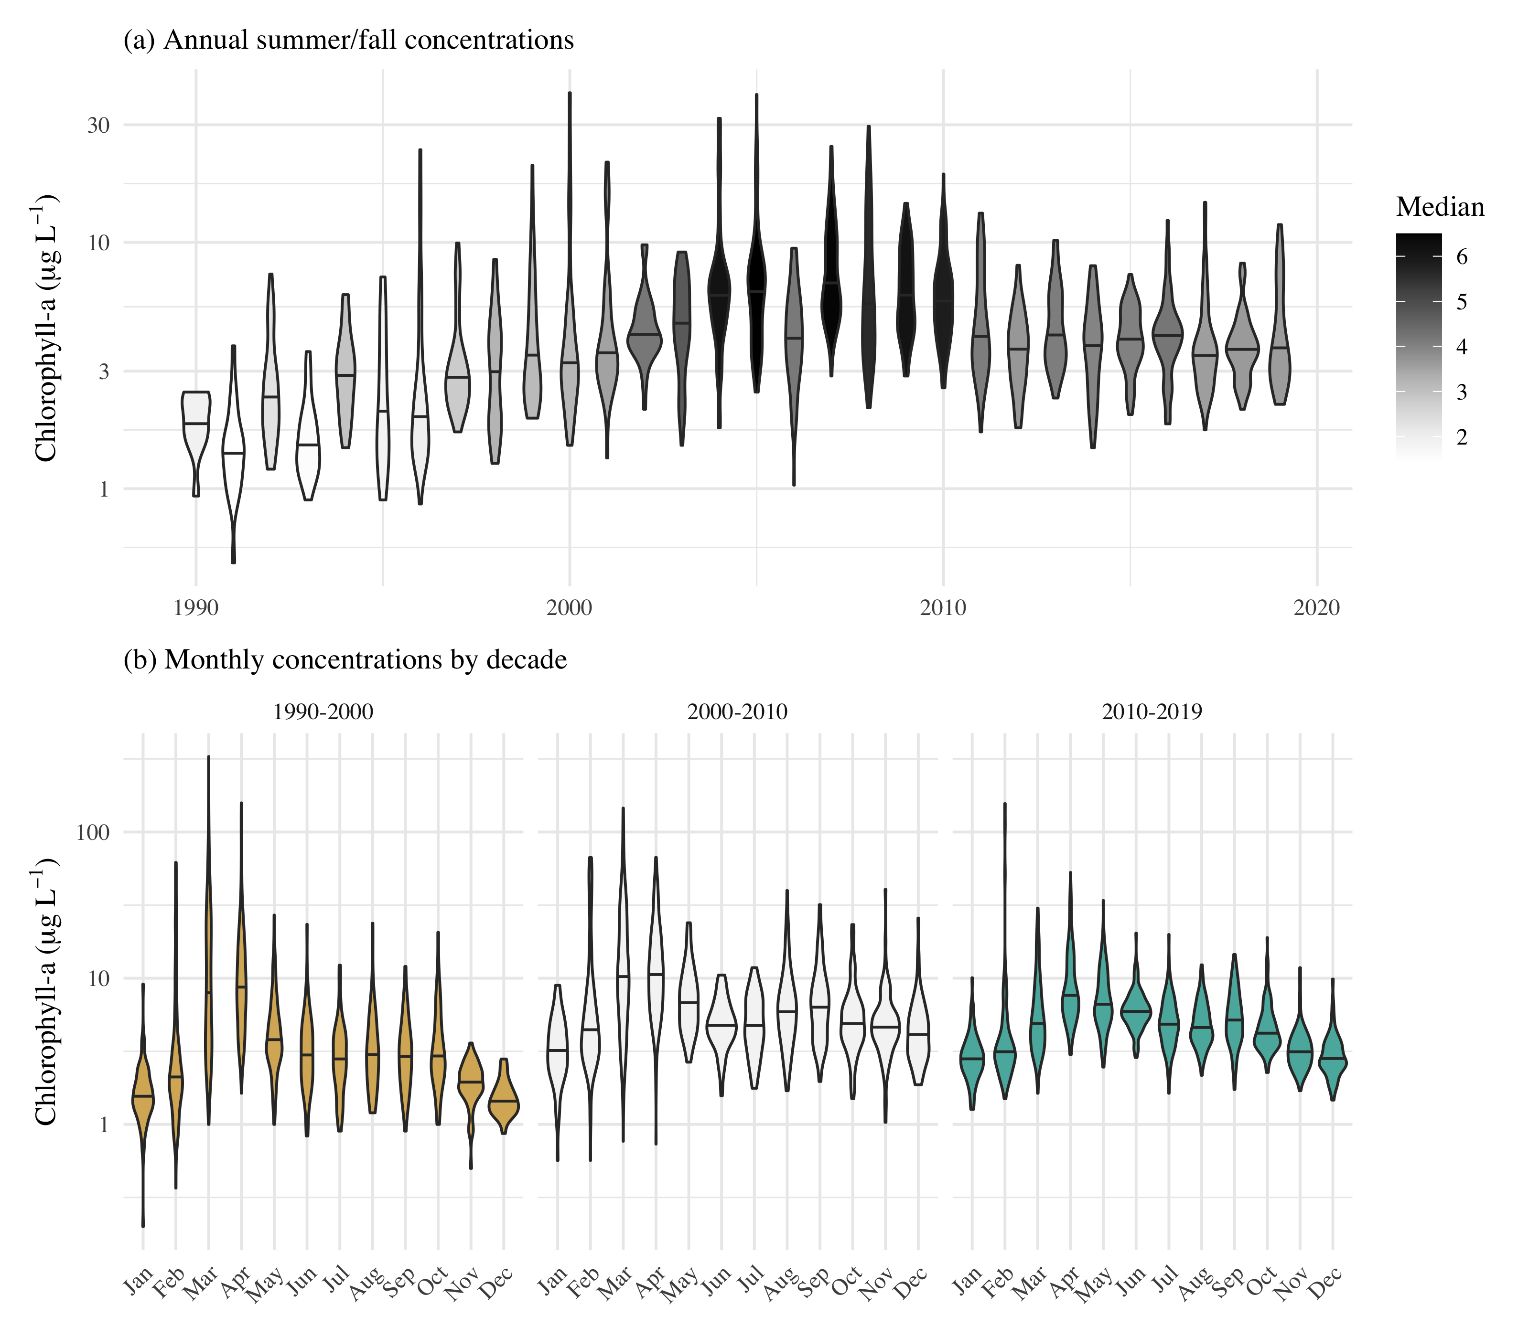

Observed chlorophyll concentrations for all stations in central and south San Francisco Estuary (18-36, Figure @ref(fig:sitemap)), with (a) annual summer/fall concentrations (Aug - Dec) and (b) monthly concentrations by decade.

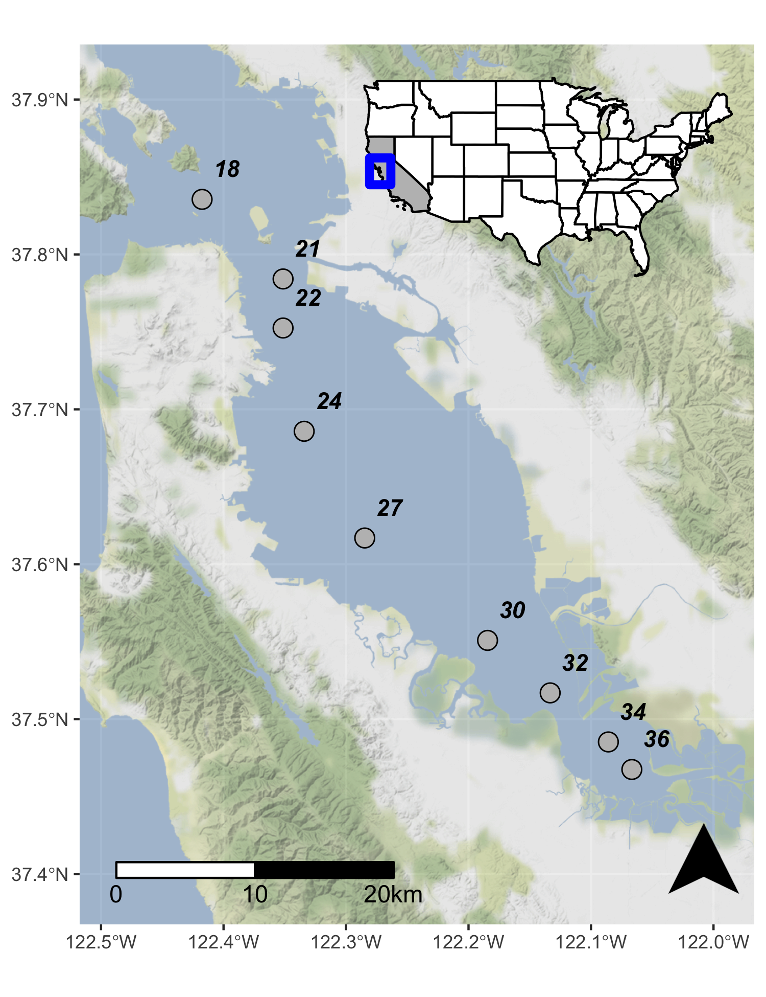

Station locations in the central and south San Francisco Estuary used for analysis. See Table @ref(tab:sumtab) for station descriptions. Full dataset described in Schraga et al. (2020).

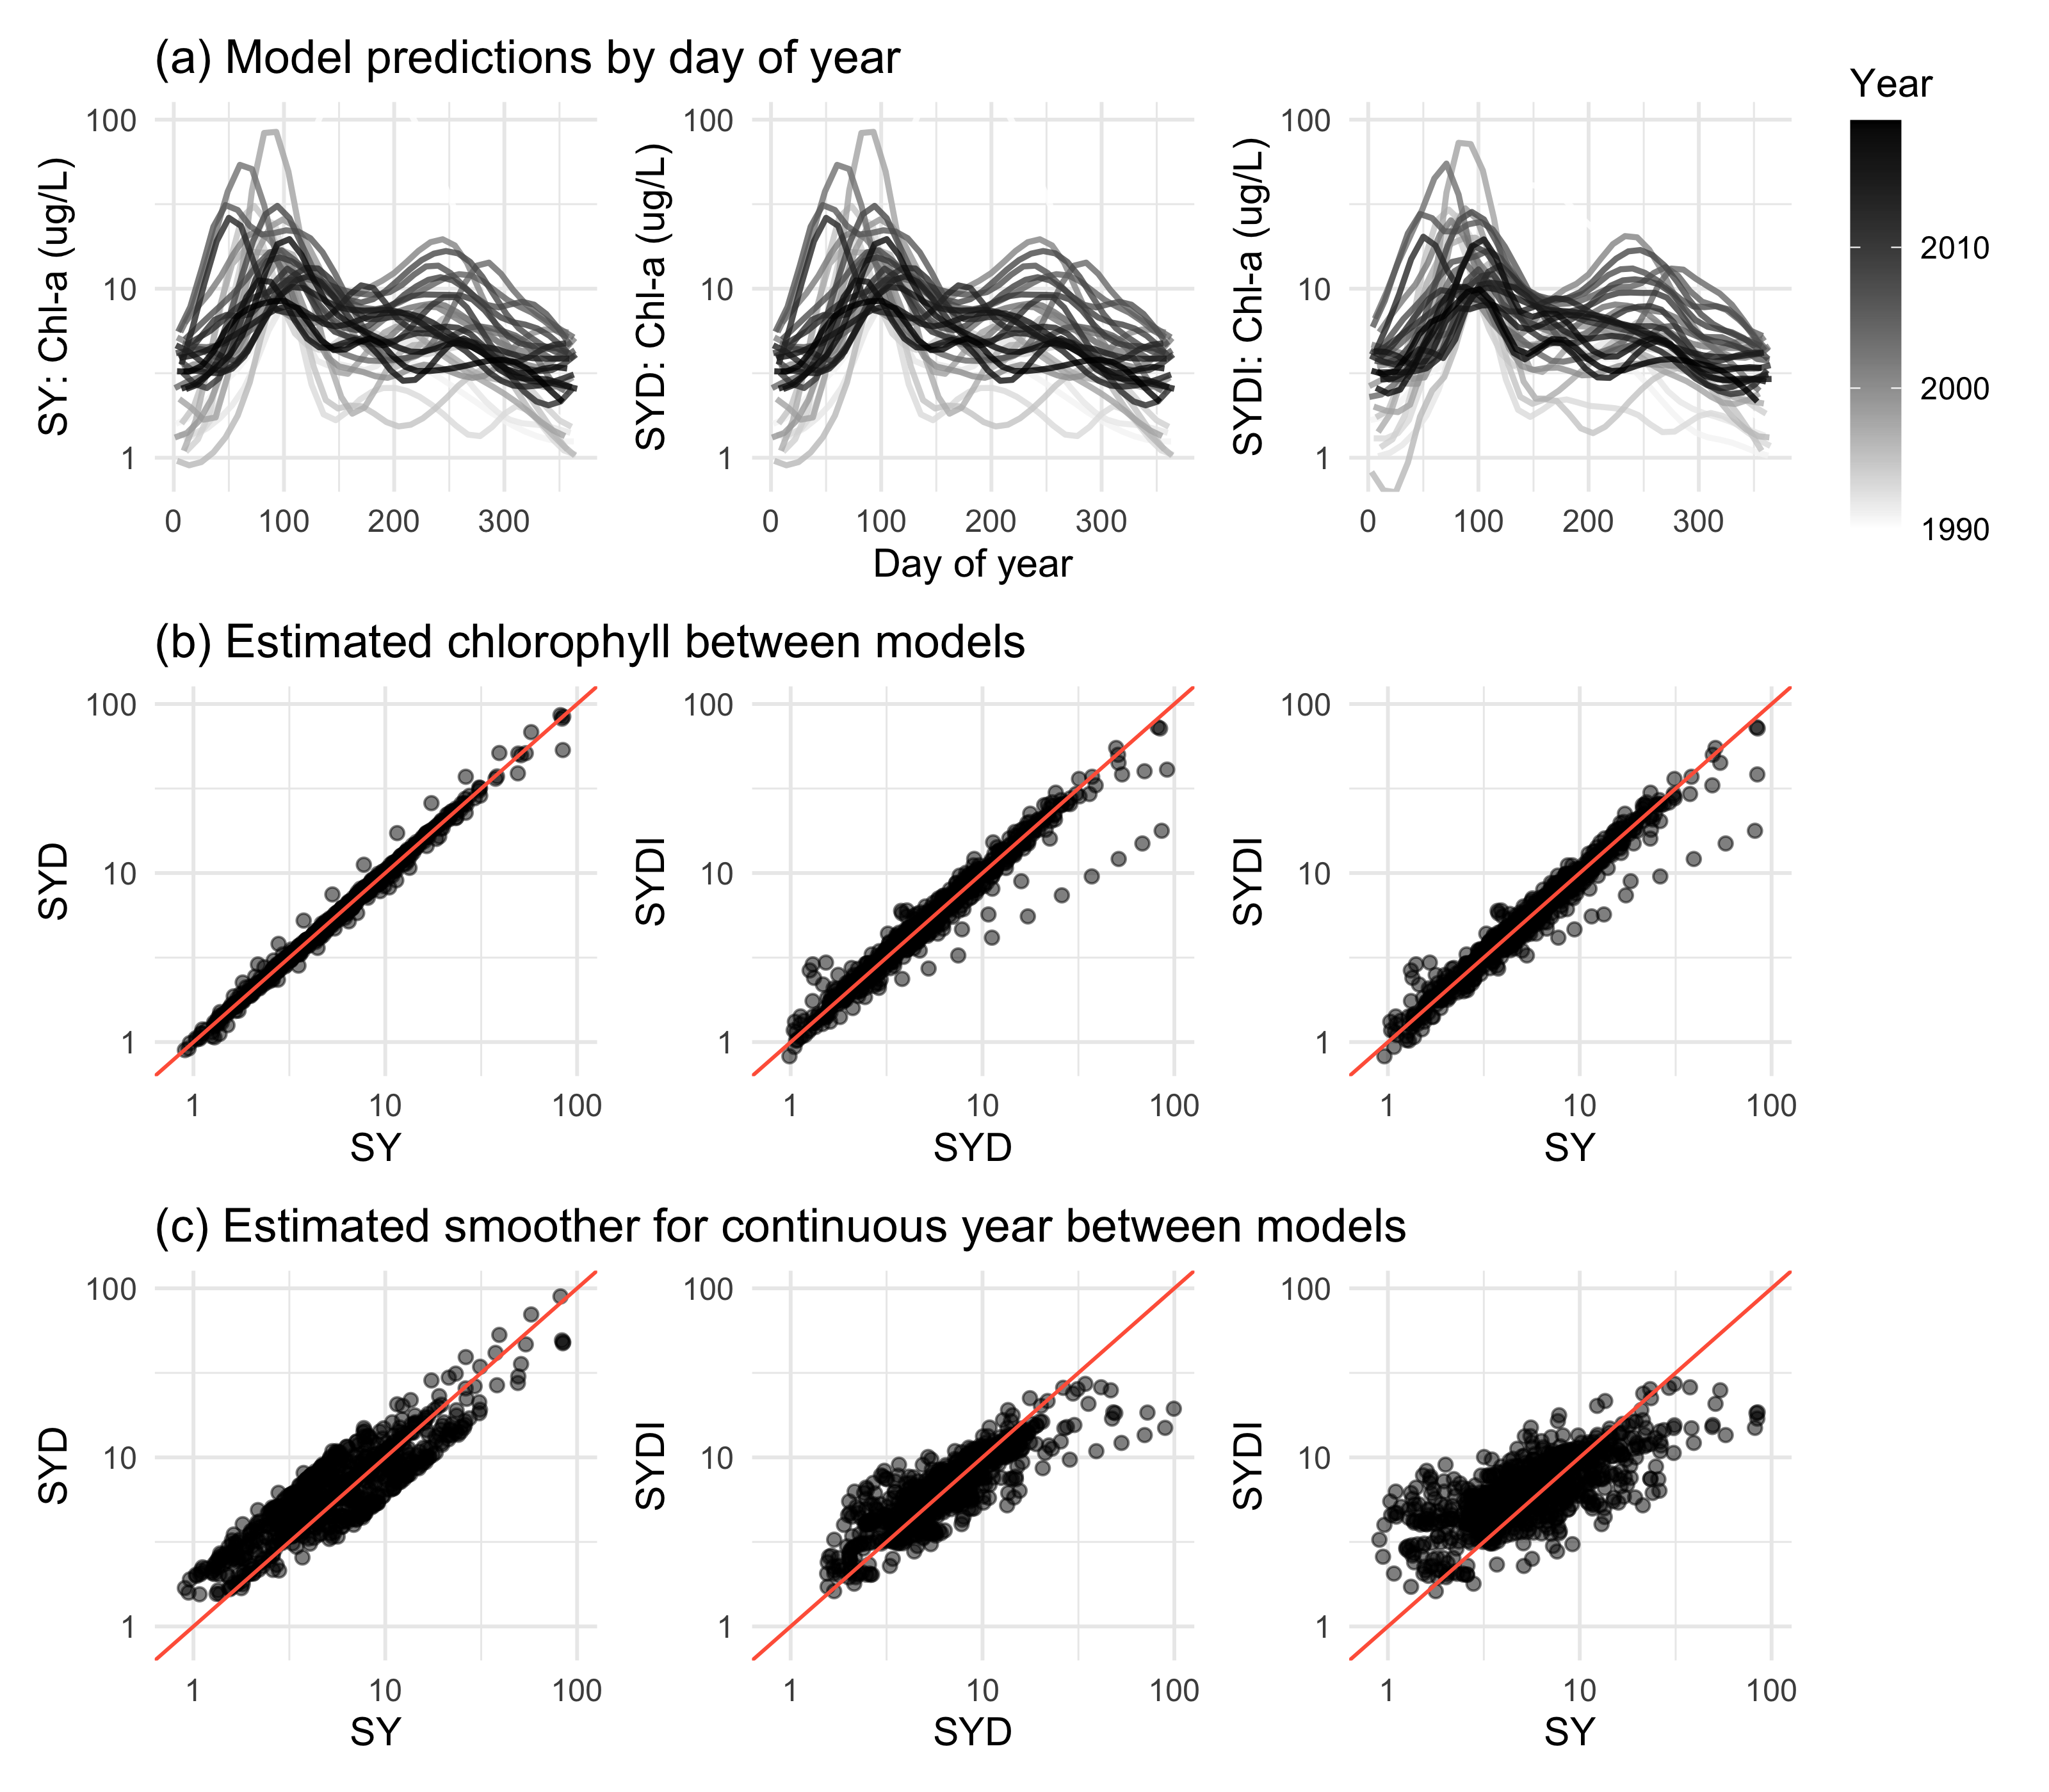

GAM output of estimated chlorophyll for models SY, SYD, and SYDI. Model S is identical to SY and is not shown. Plots in (a) show model predictions by day of year with separate lines for each year. Plots in (b) show pairwise comparisons of predicted chlorophyll between the models and plots in (c) show the same comparisons as in (b) but only for results from the estimated smoother for the cont_year variable. The plots demonstrate that results between the models are comparable except for a few observations at extreme values(a), but they vary in the penalties applied to the basis functions for any particular smoother depending on which additive components are included in each model (b). The 1:1 lines are in red to facilitate comparisons.

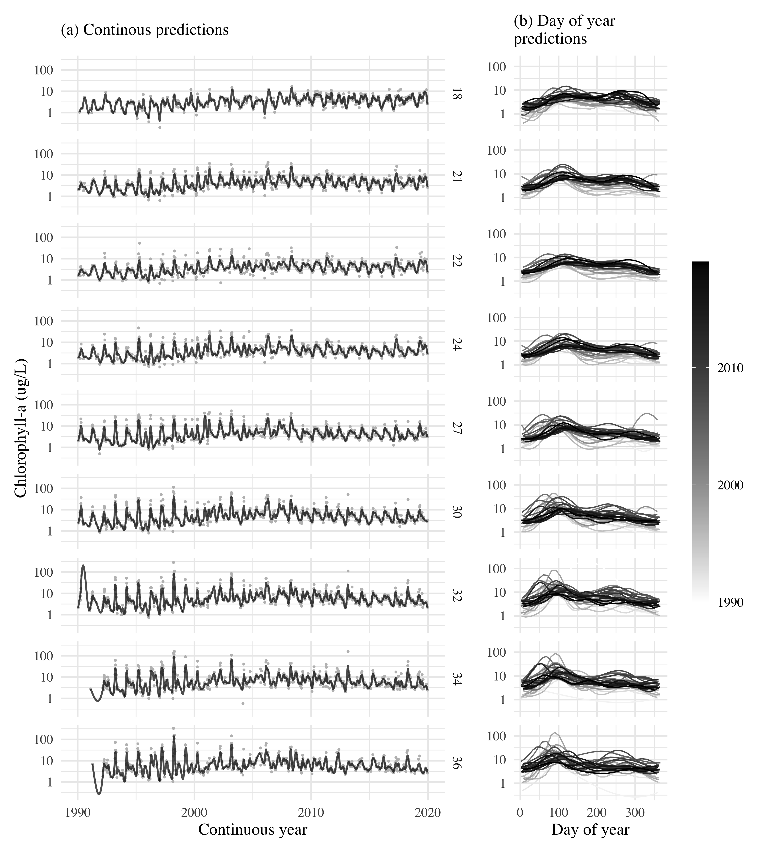

GAM predictions for all stations from north to south for model S. The results show (a) predictions across the time series and (b) predictions by day of year. Observed data in (a) are shown with the gray points. Station locations are in Figure @ref(fig:sitemap).

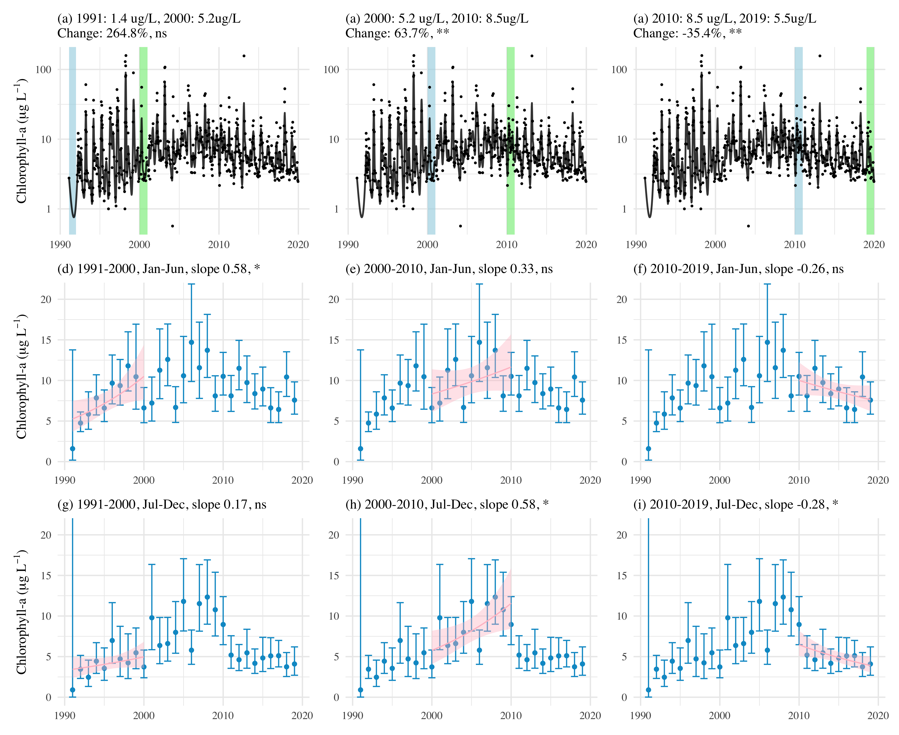

Examples of trend tests using results of GAM predictions for station 34. Plots (a), (b), and (c) show estimates of percent change as the difference of means between year pairs for chlorophyll. Plots (d) through (i) show seasonal averages and trend estimates over time. Plot (d), (e), and (f) show trend estimates for January through June and (g), (h), and (i) show trend estimates for July through December. The trend lines in (d) through (i) estimate the rate of change of chlorophyll per year, reported as the slope in the plot title. ns: not significant, * p < 0.05, ** p < 0.005

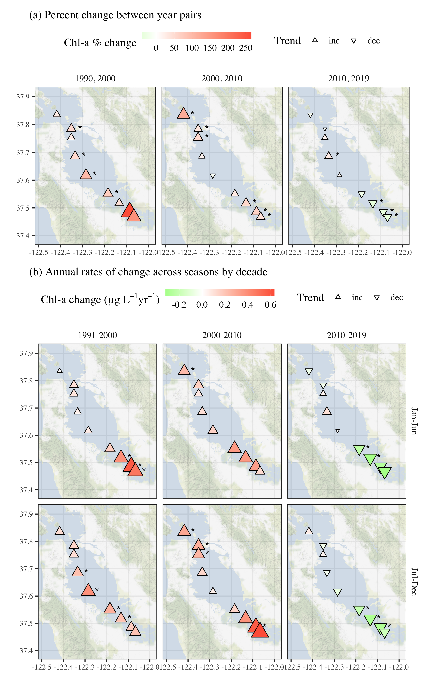

Trend estimates (a) between year pairs and (b) across seasons by decade for chlorophyll at each station. The top plots show percent change comparing the first and last year within a decade and the bottom plots show seasonal estimates of change per year for chlorophyll concentrations for each decade. Point type, shape, and color represent the direction and magnitude of an estimated trend. Trends with $p<0.05$ are marked with an asterisk. All results are from Model S.

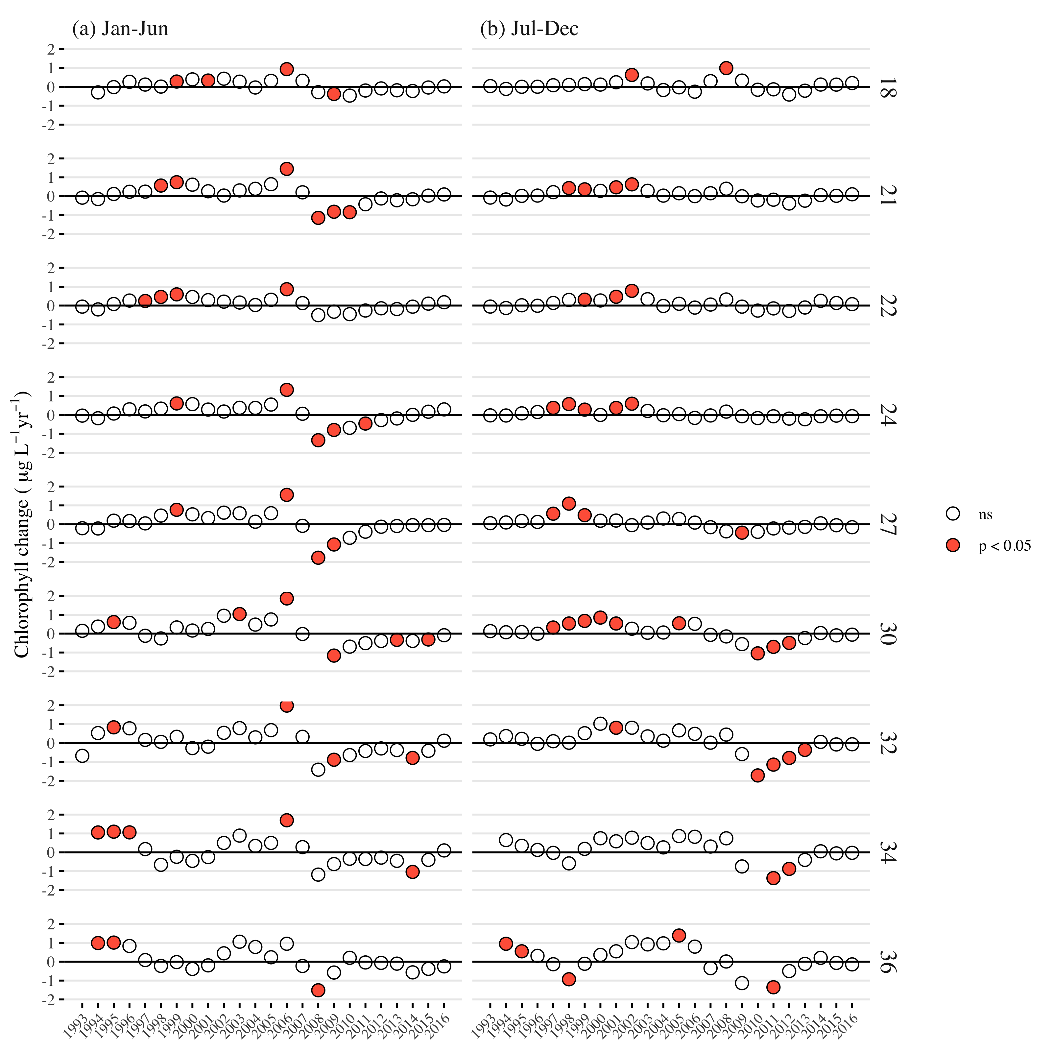

Estimates of chlorophyll change per year from applying the mixed-meta analysis across the time series for each station. Stations are arranged top to bottom from north to south. Plots in (a) show estimates for seasonal averages from January to June and plots in (b) show estimates for seasonal averages from July to December. Estimates in a year that are significant are shown in red.

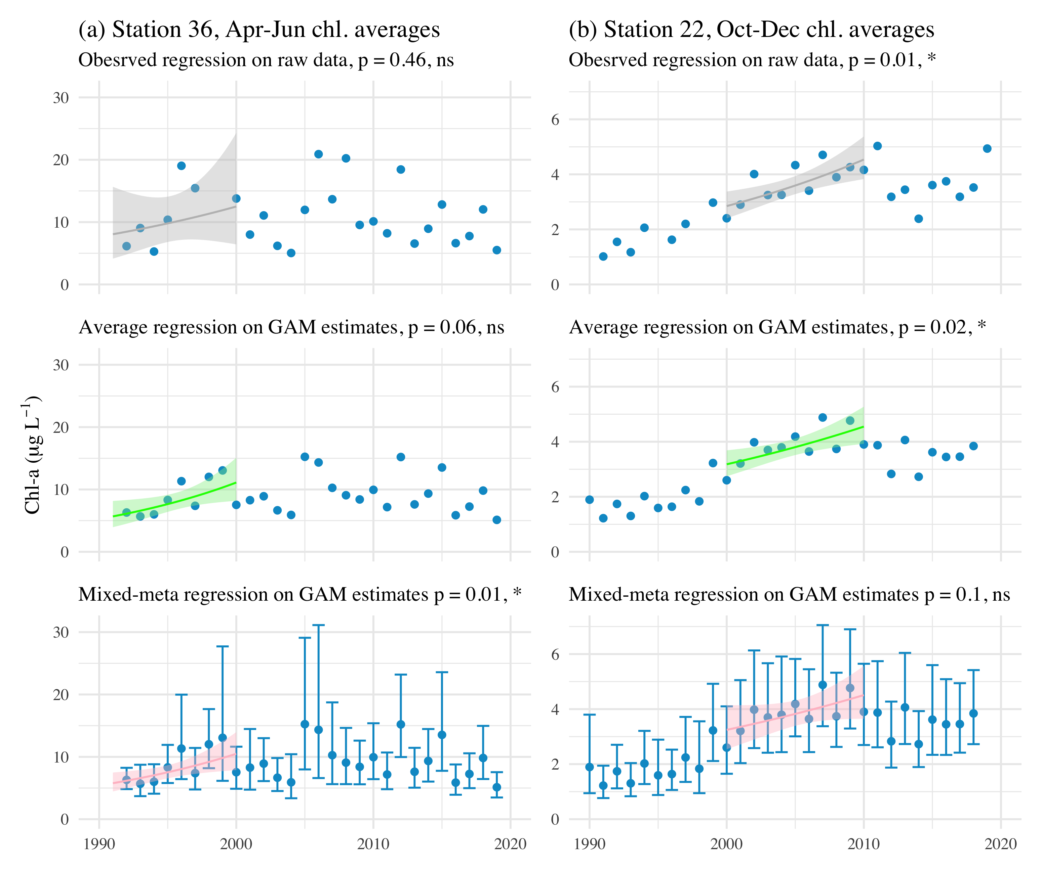

Trend estimate comparisons for three models applied to seasonal averages of chlorophyll in different annual periods at two example stations. The “observed” trend model is based on a linear fit to the annual averages of chlorophyll from the observed data, the “average” trend model is based on a linear fit to the annual averages of chlorophyll from the GAM model, and the “mixed-meta” trend model is based on a mixed-meta regression model fit to the annual averages of chlorophyll from the GAM model. Regressions in each plot are fit through the seasonal estimates indicated in the plot titles.

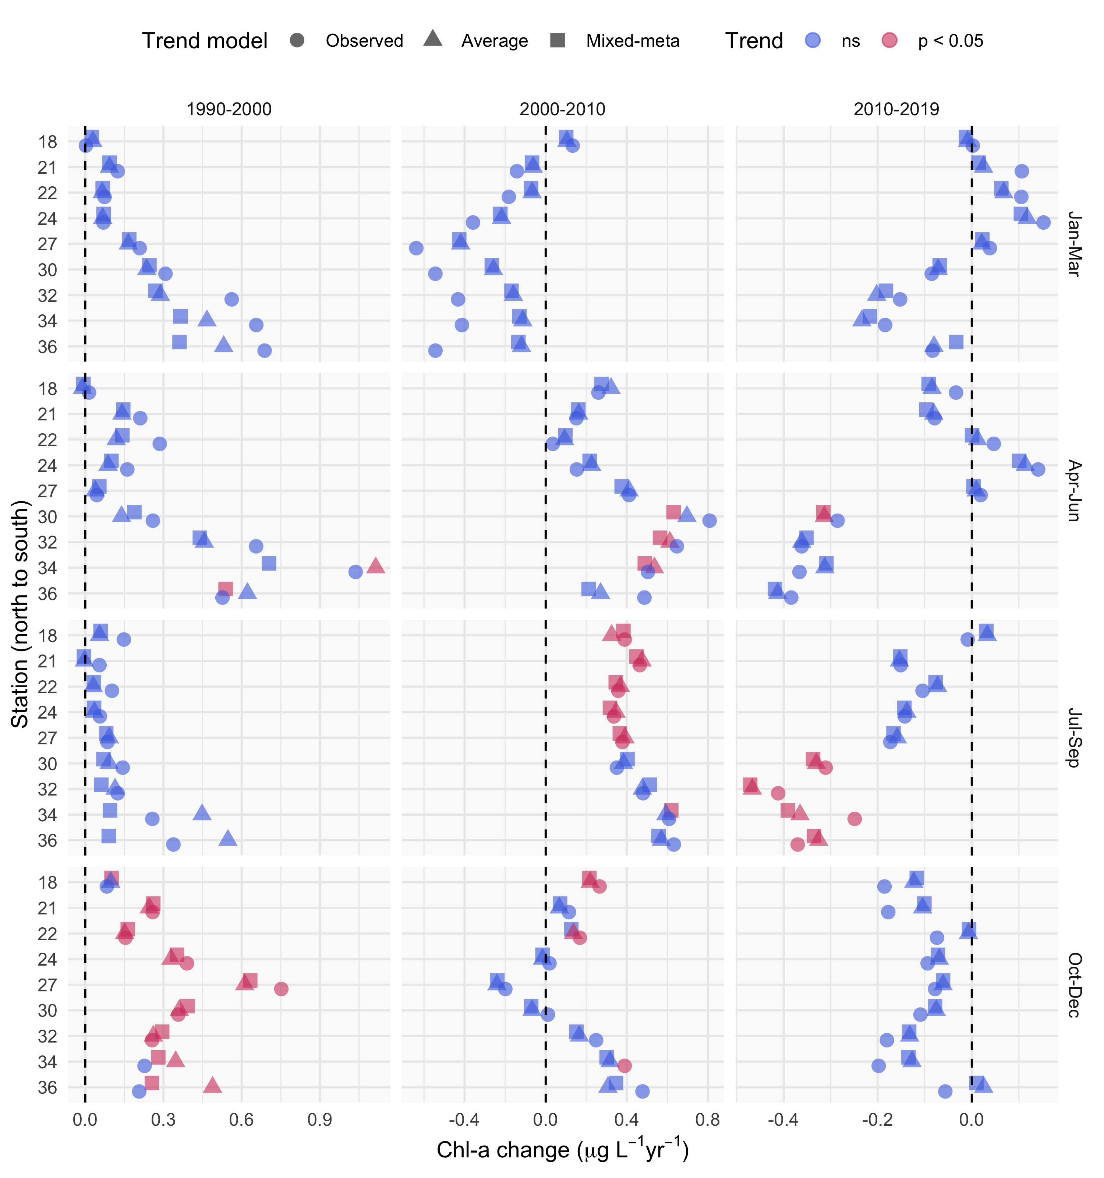

Trend estimate comparisons for three models applied to seasonal averages of chlorophyll in different annual periods at each station. The “observed” trend model is based on a linear fit to the annual averages of chlorophyll from the observed data, the “average” trend model is based on a linear fit to the annual averages of chlorophyll from the GAM model, and the “mixed-meta” trend model is based on a mixed-meta regression model fit to the annual averages of chlorophyll from the GAM model. Values for each model are the slope estimates as annual change per year within each season, with color denoting significant trends.

# Tables

Station locations, sample sizes, and summary values (median, minimum, maximum) for chlorophyll. Rows are arranged from north to south.

| Station | Latitude | Longitude | n | Med. | Min. | Max. |
| --- | --- | --- | --- | --- | --- | --- |
| 18 | 37.8 | -122 | 414 | 4 | 0.2 | 17 |
| 21 | 37.8 | -122 | 576 | 4 | 0.6 | 40 |
| 22 | 37.8 | -122 | 569 | 4 | 0.7 | 53 |
| 24 | 37.7 | -122 | 595 | 4 | 0.7 | 47 |
| 27 | 37.6 | -122 | 596 | 4 | 0.5 | 51 |
| 30 | 37.6 | -122 | 608 | 5 | 0.8 | 112 |
| 32 | 37.5 | -122 | 591 | 6 | 0.7 | 282 |
| 34 | 37.5 | -122 | 544 | 6 | 0.6 | 158 |
| 36 | 37.5 | -122 | 476 | 6 | 1.1 | 328 |

Summary and details for each of the GAM structures. In practice, a sufficiently large number of knots provided to the additive terms will produce identical or comparable estimates for a response variable. The models differ in the allocation of penalties for the smoothness of each spline (s()).

|  |  |  |
| --- | --- | --- |
| GAM | Additive components | Details |
| S | s(cont_year) | A single smoother over a continuous year variable |
| SY | cont_year + s(cont_year) | A linear continuous year variable and a single smoother over a continuous year variable |
| SYD | cont_year + s(cont_year) + s(doy) | A linear continuous year variable, a smoother over a continuous year variable, and smoother over a day of year variable |
| SYDI | cont_year + s(cont_year) + s(doy) + ti(cont_year, doy) | A linear continuous year variable, a smoother over a continuous year variable, smoother over a day of year variable, and an interaction smoother across continuous year and day of year variables |

Comparison of the four model structures (S, SY, SYD, SYDI) described in the first stage analysis of GAM estimation. The four models provide either identical or comparable ability to describe chlorophyll trends at an example station (32) in South San Francisco Estuary. The models differ in additive smoothers and the amount of effective degrees of freedom (edf) in the smoothers (measure of wiggliness in each component), but the overall model predictions are comparable. GCV: generalized cross-validation score, R2: r-squared values for predictions, edf: effective degrees of freedom, F: F-statistic, p-val: probability value, ** p < 0.001

|  |  |  |  |  |  |  |
| --- | --- | --- | --- | --- | --- | --- |
| model | GCV | R2 | smoother | edf | F | p-val |
| S | 0.06 | 0.74 | s(cont_year) | 242.23 | 6.27 | ** |
| SY | 0.06 | 0.74 | s(cont_year) | 242.23 | 6.27 | ** |
| SYD | 0.06 | 0.74 | s(cont_year) | 229.33 | 3.88 | ** |
|  |  |  | s(doy) | 8.07 | 0.11 | ** |
| SYDI | 0.06 | 0.73 | s(cont_year) | 136.88 | 3.13 | ** |
|  |  |  | s(doy) | 9.54 | 0.79 | ** |
|  |  |  | ti(cont_year,doy) | 69.31 | 0.74 | ** |

Model performance statistics for each station as generalized cross-validation scores (GCV) and r-squared values.

|  |  |  |
| --- | --- | --- |
| station | GCV | R-squared |
| 18 | 0.04 | 0.78 |
| 21 | 0.04 | 0.70 |
| 22 | 0.05 | 0.59 |
| 24 | 0.04 | 0.69 |
| 27 | 0.05 | 0.72 |
| 30 | 0.05 | 0.74 |
| 32 | 0.06 | 0.74 |
| 34 | 0.07 | 0.68 |
| 36 | 0.07 | 0.73 |

# References

Beck, M. W., and J. D. Hagy III. 2015. Adaptation of a weighted regression approach to evaluate water quality trends in an estuary. Environmental Modelling and Assessment 20:637–655.

Beck, M. W., T. W. Jabusch, P. R. Trowbridge, and D. B. Senn. 2018. Four decades of water quality change in the upper San Francisco Estuary. Estuarine, Coastal and Shelf Science 212:11–22.

Beck, M. W., and R. R. Murphy. 2017. Numerical and qualitative contrasts of two statistical models for water quality change in tidal waters. Journal of the American Water Resources Association 53:197–219.

Cleveland, R. B., W. S. Cleveland, J. E. McRae, and I. Terpenning. 1990. STL: A seasonal-trend decomposition procedure based on Loess. Journal of Official Statistics 6:3–73.

Cloern, J. E., and A. D. Jassby. 2010. Patterns and scales of phytoplankton variability in estuarine-coastal ecosystems. Estuaries and Coasts 33:230–241.

Cloern, J. E., A. D. Jassby, J. K. Thompson, and K. A. Hieb. 2007. A cold phase of the East Pacific triggers new phytoplankton blooms in San Francisco Bay. Proceedings of the National Academy of Sciences of the United States of America 104:18561–18565.

Cloern, J. E., and T. S. Schraga. 2016. USGS measurements of water quality in San Francisco Bay (CA), 1969-2015: U.S. Geological Survey data release. https://doi.org/10.5066/F7TQ5ZPR.

Cloern, J. E., T. S. Shcraga, E. Nejad, and C. Martin. 2020. Nutrient status of San Francisco Bay and its management implications. Estuaries & Coasts 43:1299–1317.

Cumming, G. S., D. H. M. Cumming, and C. L. Redman. 2006. Scale mismatches in social-ecological systems: Causes, consequences, and solutions. Ecology and Society 11:14.

Forbes, D. J., and Z. Xie. 2018. Identifying process scales in the Indian River Lagoon, Florida using wavelet transform analysis of dissolved oxygen. Ecological Complexity 36:149–167.

Fouquet, C. de. 2012. Environmental statistics revisited: Is the mean reliable? Environmental Science and Technology 46:1964–1970.

Gasparrini, A., B. Armstrong, and M. G. Kenward. 2012. Multivariate meta-analysis for non-linear and other multi-parameter associations. Statistics in Medicine 31:3821–3839.

Hafen, R. P. 2010. Local regression models: Advancements, applications, and new methods. PhD thesis, Purdue University, West Lafayette, Indiana.

Haraguchi, L., J. Carstensen, P. C. Abreu, and C. Odebrecht. 2015. Long-term changes of the phytoplankton community and biomass in the subtropical shallow Patos Lagoon Estuary, Brazil. Estuarine, Coastal and Shelf Science 162:76–87.

He, S., S. Mazumdar, and V. C. Arena. 2006. A comparative study of the use of GAM and GLM in air pollution research. Environmetrics 17:81–93.

Helsel, D. R., R. M. Hirsch, K. R. Ryberg, S. A. Archfield, and E. J. Gilroy. 2020. Statistical methods in water resources. Page 458. 2nd editions. U.S. Geological Survey Techniques; Methods, book 4, chapter A3, version 1.1, Reston, Virginia.

Hirsch, R. M., S. A. Archfield, and L. A. De Cicco. 2015. A bootstrap method for estimating uncertainty of water quality trends. Environmental Modelling and Software 73:148–166.

Hirsch, R. M., D. L. Moyer, and S. A. Archfield. 2010. Weighted regressions on time, discharge, and season (WRTDS), with an application to Chesapeake Bay river inputs. Journal of the American Water Resources Association 46:857–880.

Hirsch, R. M., J. R. Slack, and R. A. Smith. 1982. Techniques of trend analysis for monthly water quality data. Water Resources Research 18:107–121.

Hothorn, T., F. Bretz, and P. Westfall. 2008. Simultaneous inference in general parametric models. Biometrical Journal 50:346–363.

Jassby, A. D., J. E. Cloern, and B. E. Cole. 2002. Annual primary production: Patterns and mechanisms of change in a nutrient-rich tidal ecosystem. Limnology and Oceanography 47:698–712.

Junninen, H., H. Niska, K. Tuppurainen, J. Ruuskanen, and M. Kolehmainen. 2004. Methods for imputation of missing values in air quality data sets. Atmospheric Environment 38:2895–2907.

Lefcheck, J. S., D. J. Wilcox, R. R. Murphy, S. R. Marion, and R. J. Orth. 2017. Multiple stressors threaten the imperiled coastal foundation species eelgrass (*zostera marina*) in Chesapeake Bay, USA. Global Change Biology 23:3474–3483.

Morton, R., and B. L. Henderson. 2008. Estimation of nonlinear trends in water quality: An improved approach using generalized additive models. Water Resources Research 44:W07420.

Murphy, R. R., E. Perry, J. Harcum, and J. Keisman. 2019. A Generalized Additive Model Approach to evaluating water quality: Chesapeake Bay case study. Environmental Modelling & Software 118:1–13.

Navarro, G., I. Caballero, L. Prieto, A. Vázquez, S. Flecha, I. E. Huertas, and J. Ruiz. 2012. Seasonal-to-interannual variability of chlorophyll-*a* bloom timing associated with physical forcing in the Gulf of Cádiz. Advances in Space Research 50:1164–1172.

Novick, E., and D. Senn. 2014. External nutrient loads to San Francisco Bay. San Francisco Estuary Institute, Richmond, CA.

Pearce, J. L., J. Beringer, N. Nicholls, R. J. Hyndman, and N. J. Tapper. 2011. Quantifying the influence of local meteorology on air quality using generalized additive models. Atmospheric Environment 45:1328–1336.

Racault, M. F., S. Sathyendranath, and T. Platt. 2014. Impact of missing data on the estimation of ecological indicators from satellite ocean-colour time series. Remote Sensing of Environment 152:15–28.

Schraga, T. S., E. S. Nejad, C. A. Martin, and J. E. Cloern. 2020. USGS measurements of water quality in San Francisco (CA), beginning in 2016 (ver. 3.0, March 2020): U.S. Geological Survey data release. https://doi.org/10.5066/F7D21WGF.

Sera, F., B. Armstrong, M. Blangiardo, and A. Gasparrini. 2019. An extended mixed-effects framework for meta-analysis. Statistics in Medicine 38:5429–5444.

Stow, C. A., Y. Cha, L. T. Johnson, R. Confesor, and R. P. Richards. 2015. Long-term and seasonal trend decomposition of Maumee River nutrient inputs to western Lake Erie. Environmental Science and Technology 49:3392–3400.

Testa, J. M., R. R. Murphy, D. C. Brady, and W. M. Kemp. 2018. Nutrient- and climate-induced shifts in the phenology of linked biogeochemical cycles in a temperate estuary. Frontiers in Marine Science 5:1–15.

Urquhart, N. S., S. G. Paulsen, and D. P. Larsen. 1998. Monitoring for policy-relevant regional trends over time. Ecological Applications 8:246–257.

Wan, Y., L. Wan, Y. Li, and P. Doering. 2017. Decadal and seasonal trends of nutrient concentration and export from highly managed coastal catchments. Water Research 115:180–194.

Wood, S. N. 2003. Thin-plate regression splines. Journal of the Royal Statistical Society (B) 65:95–114.

Wood, S. N. 2004. Stable and efficient multiple smoothing parameter estimation for generalized additive models. Journal of the American Statistical Association 99:673–686.

Wood, S. N. 2017. Generalized additive models: An introduction with r. Page 476. 2nd editions. Chapman; Hall, CRC Press, London, United Kingdom.

Wood, S. N., and N. H. Augustin. 2002. GAMs with integrated model selection using penalized regression splines and applications to environmental modelling. Ecological Modelling 157:157–177.

Yang, G., and D. L. Moyer. 2020. Estimation of nonlinear water-quality trends in high-frequency monitoring data. Science of The Total Environment 715:10.1016/j.scitotenv.2020.136686.

Zuur, A. F., E. N. Ieno, N. J. Walker, A. A. Saveliev, and G. M. Smith. 2009. Mixed effects models and extensions in ecology with r. Page 574. Springer-Verlag, New York, New York.